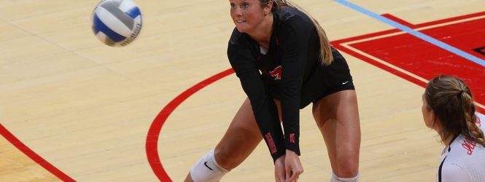
Pence gets record award as Redbirds head to Bradley
Senior Courtney Pence was named the Missouri Valley Conference Player of the Week. (Photo courtesy GoRedbirds.com)
NORMAL – Illinois State Volleyball got two wins on the road this past weekend as they swept Valparaiso Friday and Loyola of Chicago Saturday.
The Illinois State Redbirds (17-11,10-5) continued to play consistently well in sets against the two Missouri Valley Conference opponents and moved to a solid record with three regular season games remaining. Coach Johnson has featured various lineup changes in recent weeks showing her team is the type where all players can be contributing starters. Lexi Wallen and Lexi Varga were main contributing features in the two sweeps of Valparaiso and Loyola.
Senior Courtney Pence had a personal best of her own as she capped her 10th career MVC Defensive Player of the Week honor in her four-year career as a Redbird. Pence has defined true leadership and heart in her game play as her combined digs. Pence broke the record set by Northern Iowa’s Ellie Blankenship who set 9 in 2007-2010.
The Redbirds head to Bradley on the road this Saturday with the view of the upcoming MVC tournament in their sights. Coach Johnson touched on how Pence’s play and leadership have translated to her teammates as positives to help the Redbirds toward the postseason.
“Courtney has just been playing better and her style is evolving,” Coach Johnson said. “She has carried more composure lately and we are transitioning at a higher rate which can make us a competitive team for postseason.”
The Redbirds take the trip down I-74 to take on Bradley Saturday night at 7 p.m.

